

Announcement from Nakha Provincial Police Station
Subject: Intention not to accept gifts or gifts of any kind from performing duties.
(No Gift Policy)
........................................
Nakha Provincial Police Station Is committed to developing operations to be transparent. Adhere to public interest more than personal interest. There is no conflict of interest. In accordance with the national reform plan for prevention and suppression of corruption and misconduct. (revised edition) which is intended for agencies Work is carried out with transparency. without benefit All government officials do not accept gifts and favors of any kind. from performing duties (No Gift Policy)
Therefore, I would like to announce my intention. Chief Inspector, Nakha Provincial Police Station And all police officers will not accept gifts or gifts of any kind from performing their duties (No Gift Policy). Let's work together to create an organizational culture and values of honesty in our work. Do not accept the foster care system Avoid actions that may affect your judgment or decision in performing your duties. which leads to discrimination Prevent unfair performance of duties and avoid conflicts of interest. As well as building confidence in the people in performing their duties with good governance.
Therefore, it is announced for everyone to know and strictly adhere to.
Announced on March 10, 2025

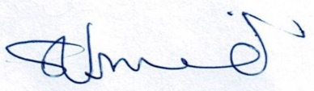
police lieutenant colonel
( Prawit Jitrart )
Chief Inspector, Nakha Provincial Police Station

